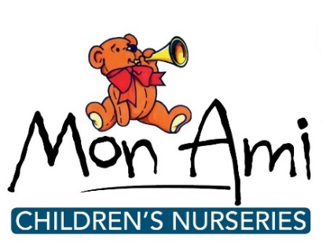
News release

20th July 2016

Lincolnshire Nursery Manager Up for National Award

An experienced nursery manager who oversees four settings in Lincolnshire has been shortlisted for a national award.

Kristina Johnson, Senior Nursery Manager at Mon Ami Children’s Nurseries, is a finalist in the Nursery Operations / Regional Manager Operations category of the Nursery World Awards.

Kristina is the manager of Mon Ami’s Boston nursery and has a supervisory role over the company’s three other settings in Alford, Swineshead and Wragby.

She will find out if she’s won the award at a presentation ceremony at the Brewery in London on Saturday 24th September 2016.

“Kristina is without a doubt an integral part of Mon Ami and a key player in our business,” said Samantha Britton, co-owner of Mon Ami Nurseries. “She is my right-hand woman without whom our nurseries would not be the success that they are.

“Kristina truly deserves to win an award such as this as it would recognise the commitment, time and determination she gives every day to working together with us and all the staffing team to make Mon Ami what it is today.”

Kristina added: “I’m amazed and delighted to have been shortlisted for this award – it’s lovely to be recognised in this way.

“If I win it will be a tribute to the whole team at Mon Ami, which is continually striving for excellence in everything we do, and to Samantha and Jarrod Britton, who work so hard to provide outstanding nursery settings for the children.”

Three of Mon Ami’s nurseries (Alford, Boston and Swineshead) are currently rated outstanding by Ofsted while the fourth (Wragby) opened last year and is yet to be inspected.

This latest accolade comes after owner Samantha Britton was named as one of the UK’s 10 most influential people in childcare by Nursery Management Today magazine in May.

She was included in the NMT Nursery Top 10 Most Influential 2016, part of NMT Nursery Top 20 organised by Nursery Management Today and sponsored by Barclays.

This month Samantha Britton and her husband Jarrod were also named in the Fantastic 50 list of top Midlands entrepreneurs in Midlands Business Insider magazine.

Notes to editors:

Mon Ami Children's Nurseries are based in Boston, Swineshead, Alford and Wragby and provide outstanding childcare and education for children aged between six weeks and eight years old.

Mon Ami offers a flexible, fully inclusive service weekdays from 7am to 6.30pm across all settings for 51 weeks of the year.

In addition, Mon Ami also runs Monti’s Children’s Club from its Alford and Swineshead sites, providing before and after-school and holiday care for children aged between four and 11 years.

Mon Ami is owned by Samantha and Jarrod Britton and opened its first nursery in Swineshead in 2002.

To find out more visit www.monaminurseries.co.uk

Like Mon Ami Nurseries on Facebook or follow on Twitter @monaminurseries

To find out more about the Nursery World awards visit www.nurseryworldawards.com

For media information contact:
Jez Ashberry
Shooting Star
01522 528540
jez@weareshootingstar.co.uk
@jezashberry
[MonAmi03nurseryworld]

