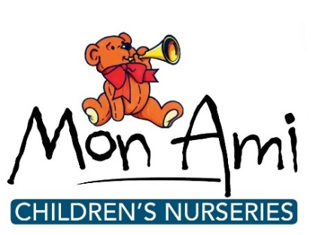
News release

15th September 2016

Mon Ami Nurseries to Stage LIVES Fundraiser

The staff and children at Mon Ami’s new nursery in Wragby are doing their bit for charity by organising a fundraising event to raise money for LIVES.

The fundraiser will take place on Wednesday 21st September in aid of the Lincolnshire Integrated Voluntary Emergency Service (LIVES).

Children will be dressing up as ‘people who help us’ such as firemen, policemen and doctors, and a sponsored walk will take place with walkers wearing their outfits.

There will be fun-filled activities for the children taking place throughout the day, such as building police cars, hospital role plays and craft activities, as well as a bake sale.

The event will take place at Mon Ami’s brand new Wragby nursery, which opened in October 2015, and at Mon Ami’s three other outstanding nurseries in Boston, Swineshead and Alford.

Vanessa Hall, Manager of Mon Ami in Wragby, said: “As well as raising money for a fantastic cause, this fundraiser will also be a great way to raise the sense of community spirit within the village.

“We’re still very new to Wragby and we’re keen to get more involved with the local community and village life.”

All money raised on the day will go to LIVES, which works alongside the East Midlands Ambulance Service in order to provide an immediate medical response in the form of first responders who are trained in first-on-scene life-saving skills.

Mon Ami chose to support LIVES as it has close connections with this charity: staff past and present have done a lot of voluntary fundraising for LIVES and some parents at the nursery support and volunteer for LIVES as fundraisers or as first responders.

Vanessa Hall added: “LIVES is an important local charity and we feel it’s important to support our local charities by doing fundraisers like this.”

The sponsored walk will take place in the morning; other activities will take place throughout the day. If you would like to attend for photographs please contact Jez at Shooting Star on 01522 528540 to confirm timings.

Notes to editors:

Mon Ami Children's Nurseries are based in Boston, Swineshead, Alford and Wragby and provide outstanding childcare and education for children aged between six weeks and eight years old.

Mon Ami offers a flexible, fully inclusive service weekdays from 7am to 6.30pm across all settings for 51 weeks of the year.

In addition, Mon Ami also runs Monti’s Children’s Club from its Alford and Swineshead sites, providing before and after-school and holiday care for children aged between four and 11 years.

Mon Ami is owned by Samantha and Jarrod Britton and opened its first nursery in Swineshead in 2002.

To find out more visit www.monaminurseries.co.uk

Like Mon Ami Nurseries on Facebook or follow on Twitter @monaminurseries

For media information please contact:
Jez Ashberry
Shooting Star
01522 528540
jez@weareshootingstar.co.uk
@jezashberry
[MonAmi06LIVES]

