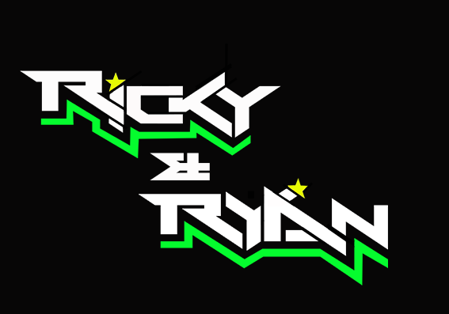
News release

23rd May 2016

Ricky and Ryan Fight Tooth and Nail in Title Defence

It was a nail-biting battle of the champions this weekend as the British title holders Ricky Stevens and Ryan Charlwood challenged the world champions for the top spot at Brands Hatch.

Sidecar driver Ricky Stevens from Portsmouth, and his passenger Ryan Charlwood from Dover, gave the Kent crowd and TV audience a show to remember in Round 2 of the Hyundai Heavy Industries British F1 Sidecar Championship. They narrowly missed out twice on first place, coming second behind Tim Reeves and Greg Cluze.

The first race on Saturday saw the pair start out in third position but after a frenetic battle with Reeves/Cluze and Peach/Richardson, they finished second with just a fraction of a second between them and the winners. They did have the honour of the claiming the fastest lap, just a tenth of a second short of the lap record.

Paul Knapton, Team Manager, said: “We made a bold change to the chassis just before the first race on Saturday, which paid off and helped us achieve a fantastic second place with a 47.6 lap time.

“The race on Sunday was even more intense and was the talking point of the whole weekend. All those who were at Brands Hatch or watched the action live on television witnessed two teams at the very top of their game.”

Prime time scheduling of the second race on Sunday afternoon and clement weather meant that a larger than usual crowd got treated to some thrilling entertainment. Ricky and Ryan fought tooth and nail with Reeves and Cluze and managed to take the lead with a hard but fair pass in the final lap. But at the next left-hander, Reeves and Cluze snatched the top spot back with a controversial move making contact with the Quattro Plant Kawasaki outfit. Ricky and Ryan once again narrowly missed out on first place by a fraction of a second.

Ryan Charlwood said: “For a moment we thought we had done it but Tim took that move straight back from underneath us. He’s a world champion for a reason, he was always going to fight back. Of course we’d have loved a first place but it’s been an exciting race.”

With still three quarters of the championship to go, Ricky and Ryan are now currently 15 points behind the top rank.

Ricky Stevens said: “What an amazing weekend that was! Even though we didn’t quite get to the top step of the podium, those two battles with Tim were exhilarating. The bike worked really well in both races and that is credit to the team’s hard work and dedication. Knockhill is coming up next and we’ll try to repeat our double victory of 2015.”

Ends

Notes to editors:

- Ricky and Ryan are the reigning British F1 Sidecars champions.
- They raced to victory in the 2015 championship for team AOS/Be Wiser with Ricky Stevens, from Portsmouth, as driver and Ryan Charlwood, from Dover, as co-rider.
- In 2015, they also beat the world champions by four seconds, effectively making them the best F1 sidecar racing team in the world at present.
- For the 2016 season, Ricky and Ryan have joined the Quattro Plant Cool Kawasaki team. The newly sponsored team has a new livery and the backing from Bournemouth Kawasaki. The Quattro Plant Cool team also includes British Superbike riders Luke Mossey and Filip Backlund and Supersport rider Andy Reid.

For media information contact:
Sarah-Jane Freni
Account Director
Shooting Star
0117 3131120
sarahjane@weareshootingstar.co.uk

