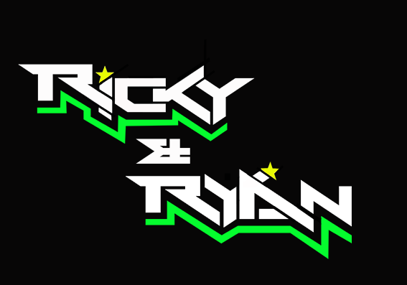

**News release**

23rd June 2016

**Ricky and Ryan Look Forward to a Pivotal Weekend**

**2015 British F1 Sidecar champions Ricky Stevens and Ryan Charlwood are headed north of the border for round 3 of the championship. They are hoping to top last year’s double victory.**

Round 3 of the 2016 [Hyundai Heavy Industries British Sidecar Championship](http://www.rkb-f1-sidecars.com/index.html) will take place in Knockhill, Scotland, this weekend. It is a three-race round, meaning that the stakes are high for [Ricky and Ryan](http://www.teamrickyandryan.com), ~~the reigning champions,~~ who currently rank second in the championship.

The weekend could be ~~a~~ pivotal ~~one~~ as the current leaders Tim Reeves and Greg Cluze have a dilemma**.** The Knockhill round clashes with the Hungarian round of the world championship which they also lead. With three races they potentially stand to lose 75 points and their lead in the British championship.

Ryan said: “We don’t know yet if Tim and Greg will be at Knockhill ~~to fight for their lead~~. We would almost certainly get the lead if they don’t come but to be honest, we would prefer beating them on the track rather than by default, especially after our nail-biting fight for the top spot at the last round.”

The [Quattro Pant Cool Kawasaki](http://www.quattroplantkawasaki.com) pair chased Reeves and Cluze to within a fraction of a second at Brands Hatch in May and only narrowly missed out on first place.

The team have ensured they are fully prepared for some more exciting racing action this weekend, regardless of whether their greatest rivals are on track or not. They have switched their engine and made some tweaks to their suspension, which they hope will improve their acceleration.

Ricky added: “We ran some tests at the Llandow circuit in Wales a couple of weeks ago and I was pleased with how the outfit performed.

“Last year at Knockhill we secured a double victory. We’d love to top that by winning all three races this year.”

The Sunday race will be shown live on [Eurosport](http://www.eurosport.co.uk).

**Ends**

**Notes to editors:**

* Ricky and Ryan are the reigning British F1 Sidecars champions.
* They raced to victory in the 2015 championship for team AOS/Be Wiser with Ricky Stevens, from Portsmouth, as driver and Ryan Charlwood, from Dover, as co-rider.
* In 2015, they also beat the world champions by four seconds, effectively making them the best F1 sidecar racing team in the world at present.
* For the 2016 season, Ricky and Ryan have joined the Quattro Plant Cool Kawasaki team. The newly sponsored team has a new livery and the backing from Bournemouth Kawasaki. The Quattro Plant Cool team also includes British Superbike riders Luke Mossey and Filip Backlund and Supersport rider Andy Reid.

**For media information contact:**

**Sarah-Jane Freni**

**Account Director**

**Shooting Star**

**0117 3131120**

[**sarahjane@weareshootingstar.co.uk**](mailto:sarahjane@weareshootingstar.co.uk)