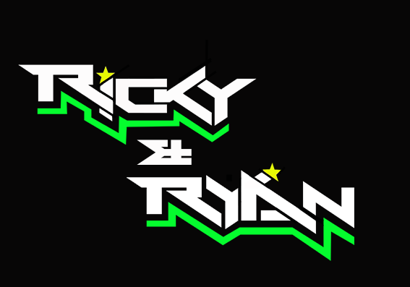

**News release**

27th June 2016

**Challenging Round 3 for Ricky and Ryan**

**2015 British F1 Sidecar champions Ricky Stevens and Ryan Charlwood were aiming for a triple victory this weekend but their hopes were dashed when Ryan dislocated his shoulder during practice on Friday.**

Round 3 of the 2016 [Hyundai Heavy Industries British Sidecar Championship](http://www.rkb-f1-sidecars.com/index.html) took place in Knockhill, Scotland, at the weekend. This was a three-race round and the pair’s main rivals were absent owing to a date clash with the world championship, so the stakes were high for [Ricky and Ryan](http://www.teamrickyandryan.com).

The weekend got off to a bad start with Ryan falling off the outfit during the first practice session. He dislocated his shoulder in the process and was unable to take part in the rest of the weekend’s racing action.

Ryan said: “I tried to cling on to the outfit with the G force fighting against me and that is how I dislocated my shoulder. I realised almost immediately that something was wrong and it was a serious injury.

“I’m really disappointed. Knockhill is my favourite circuit and this was going to be a pivotal weekend for us. I was really looking forward to it.”

With Andy Peach being away from the championship this weekend through ill health, his passenger Charlie Richardson stepped in and went out on the track with Ricky in all three races.

Despite a very short practice session, Ricky and Charlie managed to secure P3 in the qualifiers.

An encounter with another outfit at the start of the first race on Saturday led to a spin and saw the pair finish the first lap last. They managed to claw back some time over the course of the race and finished eighth. The second race on Saturday saw them finish in third position.

On Sunday, the pair looked set to win as they took the lead for four laps but a spin on lap eight dropped them back to third place.

Ricky said: “We had hoped for a triple victory this weekend so I’m somewhat disappointed with the result.

“Losing Ryan was obviously a game changer - part of our success is that we are so well matched.

“But Charlie is an experienced passenger and we are so grateful to Andy Peach and their sponsors that they let us have him for the weekend.

“At the end of the day, I’ve not done as well as I’d hoped but I have still come away leading the championship and that is definitely cause for a celebration.”

Ricky and Ryan now rank first in the British F1 Sidecar championship with a 17-point lead.

The next round of the championship will take place at Snetterton from 8th to 10th July and Ryan is expected to have made a full recovery by then.

**Ends**

**Notes to editors:**

* Ricky and Ryan are the reigning British F1 Sidecars champions.
* They raced to victory in the 2015 championship for team AOS/Be Wiser with Ricky Stevens, from Portsmouth, as driver and Ryan Charlwood, from Dover, as co-rider.
* In 2015, they also beat the world champions by four seconds, effectively making them the best F1 sidecar racing team in the world at present.
* For the 2016 season, Ricky and Ryan have joined the Quattro Plant Cool Kawasaki team. The newly sponsored team has a new livery and the backing from Bournemouth Kawasaki. The Quattro Plant Cool team also includes British Superbike riders Luke Mossey and Filip Backlund and Supersport rider Andy Reid.

**For media information contact:**

**Sarah-Jane Freni**

**Account Director**

**Shooting Star**

**0117 3131120**

[**sarahjane@weareshootingstar.co.uk**](mailto:sarahjane@weareshootingstar.co.uk)