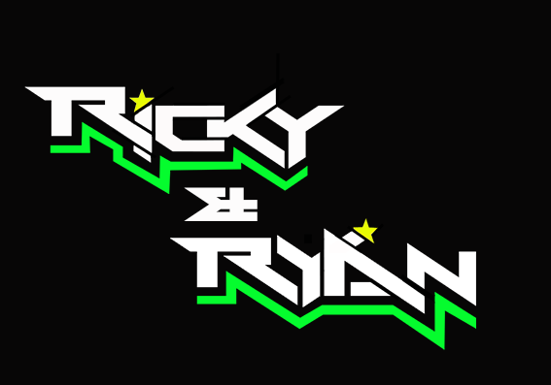

**News release**

4th July 2016

**Team Ricky and Ryan is Reunited for Snetterton**

**After their major setback at Knockhill at the end of June, British F1 Sidecar champions Ricky Stevens and Ryan Charlwood are back together for round 4 of the championship at Snetterton, Norfolk.**

Round 3 of the [Hyundai Heavy Industries British Sidecar Championship](http://www.rkb-f1-sidecars.com/index.html) didn’t go swimmingly for Team [Ricky and Ryan](http://www.teamrickyandryan.com) after Ryan fell off the outfit during the first practice session and dislocated his shoulder in the process.

Passenger Charlie Richardson stood in for Ryan, making it possible for Ricky to secure the lead in the championship.

Ricky said: ““Losing Ryan before the racing had even begun was obviously a game changer - part of our success is that we are so well matched.

“We had hoped for a triple victory that weekend, which would have put us in a really comfortable place for the rest of the championship, but we had to settle for an eighth and two third places.

“We did manage to grab the lead the championship but as we’re only 17 points ahead of the competition, we will have to keep fighting tooth and nail to remain at the top of the rankings.”

With just two weeks between round 3 and round 4, Ryan has been on an intense recovery programme which has included daily treatments and gentle exercise.

Ryan said: “This injury couldn’t have come at a worse time. From round 3 onwards, the racing schedule is pretty ruthless with two weeks or less between each rounds.

“I have had almost daily sessions in an hyperbaric chamber to speed up the recovery process. I have also undergone laser therapy and physiotherapy and the therapists are really positive about the way my shoulder has healed.

“I’ve also had to adapt my exercise routine. In order to regain the strength I need to race, gentle and low-impact exercise has been key.”

Ricky and Ryan will race at 1.35pm on Saturday and 5.25pm on Sunday.

**Ends**

**Notes to editors:**

* Ricky and Ryan are the reigning British F1 Sidecars champions.
* They raced to victory in the 2015 championship for team AOS/Be Wiser with Ricky Stevens, from Portsmouth, as driver and Ryan Charlwood, from Dover, as co-rider.
* In 2015, they also beat the world champions by four seconds, effectively making them the best F1 sidecar racing team in the world at present.
* For the 2016 season, Ricky and Ryan have joined the Quattro Plant Cool Kawasaki team. The newly sponsored team has a new livery and the backing from Bournemouth Kawasaki. The Quattro Plant Cool team also includes British Superbike riders Luke Mossey and Filip Backlund and Supersport rider Andy Reid.

**For media information contact:**

**Sarah-Jane Freni**

**Account Director**

**Shooting Star**

**0117 3131120**

[**sarahjane@weareshootingstar.co.uk**](mailto:sarahjane@weareshootingstar.co.uk)

**[RickyRyan07Snetterton]**