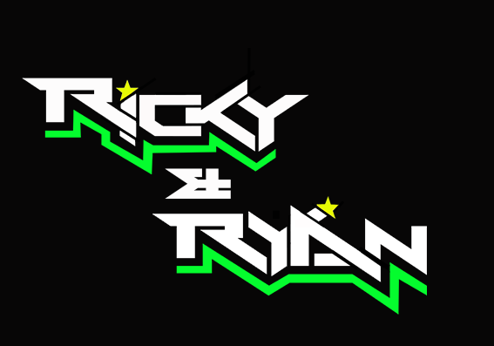

**News release**

27th July 2016

**Teenage Cancer Trust Patients Meet Sidecar Champions**

**British F1 sidecar champions** [**Ricky Stevens and Ryan Charlwood**](http://www.teamrickyandryan.com) **welcomed a group from the Bristol unit of the Teenage Cancer Trust at Thruxton on Saturday.**

Sidecar driver Ricky Stevens, from Portsmouth, and his passenger Ryan Charlwood, from Dover, were competing at the track in Hampshire last weekend in the fifth round of the British F1 Sidecar Championship, part of the British Superbike series.

The pair had invited patients of the Bristol unit of the Teenage Cancer Trust to join them for a day out at the races.

Ricky said: “Giving back to the community is really important to us. We wanted to get involved with the Teenage Cancer Trust because we admire the work they do.

“Hosting a visit for the young people in their care is easy for us really and if it can take their mind off the disease for a day, then it’s well worth it.”

A small delegation comprising three patients, their parents and a Teenage Cancer Trust representative responded to the invite and were given the opportunity to meet the champions and their fellow Quattro Plant Cool Kawasaki teammates.

The group arrived shortly after 9.30am on Saturday and were taken to the sidecar team's hospitality suite to have brunch and meet their hosts, Ricky and Ryan. They had a proper look at the F1 sidecar, from the motor to the fairing, and received some racing insights from the whole team.

In the days running up to the visit, Ricky and Ryan had raised awareness of the charity’s work via social media and invited their fans to help raise money for the Teenage Cancer Trust by making a donation via the team's JustGiving page. The pair then handed over a cheque to the young visitors and their carers.

The guests then visited the Quattro Plant Cool Kawasaki garage and were introduced to Ricky and Ryan’s team mates, superbike riders Luke Mossey and Filip Backlund and supersport rider Andy Reid.

Pete Extance, the team owner, gave the delegation a thorough explanation of how the garage operates. Everyone’s motorbikes were also on show and were much admired by the visitors.

In the afternoon, the group got to enjoy some racing action and witness Ricky and Ryan win not just one but both races.

Ryan said: “It was an eventful weekend for us but meeting these young people and being faced with their battle puts everything in perspective. I was really inspired by their bravery and cheerfulness in spite of everything they're going through."

**Ends**

**Notes to editors:**

**About Ricky and Ryan**

* Ricky and Ryan are the reigning British F1 Sidecars champions.
* They raced to victory in the 2015 championship for team AOS/Be Wiser with Ricky Stevens, from Portsmouth, as driver and Ryan Charlwood, from Dover, as co-rider.
* In 2015, they also beat the world champions by four seconds, effectively making them the best F1 sidecar racing team in the world at present.
* For the 2016 season, Ricky and Ryan have joined the Quattro Plant Cool Kawasaki team. The newly sponsored team has a new livery and the backing from Bournemouth Kawasaki. The Quattro Plant Cool team also includes British Superbike riders Luke Mossey and Filip Backlund and Supersport rider Andy Reid.

**About Teenage Cancer Trust**

* Teenage Cancer Trust opened the South West’s first specialist unit for young people aged 16 – 24 years old with cancer at the Bristol Haematology and Oncology Centre in June 2014.
* This unit compliments the ward they opened in 2012 at the Bristol Royal Hospital for Children for 11 – 16 year olds.
* For the first time young people with cancer from across the region can now be treated alongside others the same age, by staff who are teenage cancer experts, in a space specially designed to meet their unique needs.

**For media information contact:**

**Sarah-Jane Freni**

**Account Director**

**Shooting Star**

**0117 3131120**

[**sarahjane@weareshootingstar.co.uk**](mailto:sarahjane@weareshootingstar.co.uk)

**[RickyRyan11TCT]**