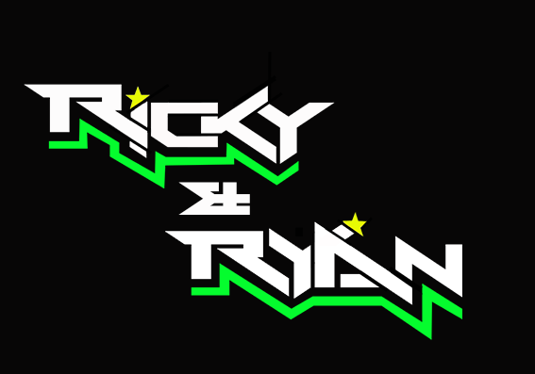

**News release**

1st August 2016

**Double Victory for Team Ricky and Ryan at Mallory Park**

**Round 6 of the** [**F1 sidecar championship**](rkb-f1-sidecars.com) **took place at Mallory Park, Leicestershire, over the weekend. Champions** [**Ricky Stevens and Ryan Charlwood**](http://www.teamrickyandryan.com) **regained the top spot in the rankings by winning both races.**

After a controversial third race at Thruxton the week before, which saw them relegated to second place, sidecar driver Ricky Stevens, from Portsmouth, and his passenger Ryan Charlwood, from Dover, managed to regain a comfortable lead over their main competitors at the Mallory Park Bike Bonanza.

A large crowd saw the racing pair take fourth place in the qualifier on Saturday in near perfect conditions and on an old set of tyres. With new tyres for the Sunday races, hopes were high that they could get back to winning ways, and they didn’t disappoint.

Ricky said: “We went into the first race on Sunday quietly confident. I was relaxed and determined to enjoy the action and that really paid off.

“We were nose-to-tail the whole time with Ben Holland and Lee Watson, the Birchall brothers and Chris Walker and Ashley Hawes but we managed to get away.

“We started experiencing misfiring issues, which slowed us down but we still managed to win by half a second. It was a cracking race.”

In the second race, Ricky and Ryan grabbed the advantage from the start and finished with a 4.7 seconds lead when the race was red flagged after 12 laps due to an incident between two other teams.

Ricky and Ryan now lead the championship with 33 points ahead of Ben Holland and Lee Watson and 42 points ahead of previous challengers Tim Reeves and Greg Cluze.

The next round of the RKB-F1 Sidecar Championship is at Donington Park in six weeks’ time. This round will also have a round of the world sidecar championship where the British teams can compete against the best in the world.

Ryan said: “This weekend’s victories were made possible by excellent teamwork. We’re really lucky to have an amazing group of people around us and to be part of the [Quattro Plant Cool Kawasaki’s team](http://www.quattroplantkawasaki.com). Their technical support came in very handy on Sunday after our misfiring issues.

“We are going to use the six weeks downtime to make improvements to the outfit. I also need to work on my fitness after my shoulder injury at Knockhill last month.

“It’s been a great weekend and it’s given us renewed confidence for the last three rounds.”

**Ends**

**Notes to editors:**

* Ricky and Ryan are the reigning British F1 Sidecars champions.
* They raced to victory in the 2015 championship for team AOS/Be Wiser with Ricky Stevens, from Portsmouth, as driver and Ryan Charlwood, from Dover, as co-rider.
* In 2015, they also beat the world champions by four seconds, effectively making them the best F1 sidecar racing team in the world at present.
* For the 2016 season, Ricky and Ryan have joined the Quattro Plant Cool Kawasaki team. The newly sponsored team has a new livery and the backing from Bournemouth Kawasaki. The Quattro Plant Cool team also includes British Superbike riders Luke Mossey and Filip Backlund and Supersport rider Andy Reid.

**For media information contact:**

**Sarah-Jane Freni**

**Account Director**

**Shooting Star**

**0117 3131120**

[**sarahjane@weareshootingstar.co.uk**](mailto:sarahjane@weareshootingstar.co.uk)

**[RickyRyan12MalloryPark]**