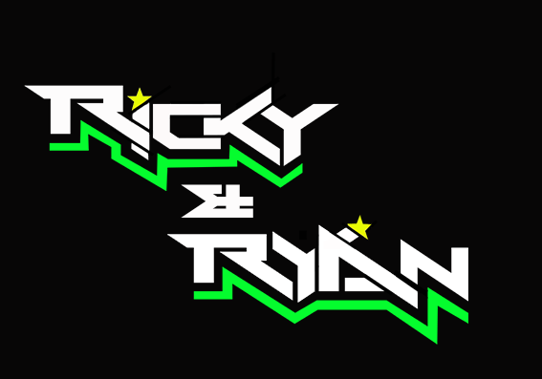

**News release**

12th September 2016

**Sidecar Duo Ricky and Ryan are Raring to Go!**

**Round 7 of the 2016** [**British F1 Sidecar Championship**](http://www.rkb-f1-sidecars.com) **is taking place at Donington Park this weekend, after a six-week break.**

Reigning champions [Ricky Stevens and Ryan Charlwood](http://www.teamrickyandryan.com) are gearing themselves up for a fight to extend their lead in the rankings even further.

Sidecar driver Ricky Stevens, from Portsmouth, and his passenger Ryan Charlwood, from Dover, head to the Leicestershire circuit this weekend for the seventh round of the championship. With just three rounds to go and holding a 33-point lead in the championship, the team has everything to race for and will be defending its top spot with fierce determination.

Spectators at Donington Park will see Ricky and Ryan go head to head with arch rivals Tim Reeves and Greg Cluze and current second place holders Ben Holland and Lee Watson. After a difficult and controversial round at Thruxton in July, Ricky and Ryan regained their lead in the championship by securing a double victory at Mallory Park in round 6.

Ryan said: “The championship this year has been far from plain sailing for us but we are as determined as ever to defend our title.

“We are leading at the moment but only by 33 points so we’re not taking anything for granted at this stage. We have to keep the wins coming or we are in danger of missing out.”

Despite a six-week gap between rounds, the pair has had no time to rest. In between their full-time jobs away from the races, showing support to their [Quattro Plant Cool Kawasaki team](http://www.quattroplantkawasaki.com/) mates at Brands Hatch and Cadwell Park and mentoring the next generation of racing talent at the [Cool FAB British Minibike Championship](http://www.coolfabracing.com/), Ricky and Ryan have spent all their free time making a series of improvements to their sidecar.

Ricky said: “'We have installed a new 2016 Kawasaki motor and have been improving the aerodynamics and the airflow in and around the outfit. It’s been relentless work but we’ve received a lot of support for which we are extremely grateful.

“We’ve been testing the improved outfit at Mallory Park this weekend and I’m really pleased with the result. I can’t wait to show her off at Donington.”

Donington is a three-race round. The race on Saturday is a combined world and British championship event and will see a record number of 39 sidecars taking their position on the grid. Ricky and Ryan won the combined race last year, beating the world champions. They are hoping to repeat this feat this year.

**Ends**

**Notes to editors:**

* Ricky and Ryan are the reigning British F1 Sidecars champions.
* They raced to victory in the 2015 championship for team AOS/Be Wiser with Ricky Stevens, from Portsmouth, as driver and Ryan Charlwood, from Dover, as co-rider.
* In 2015, they also beat the world champions by four seconds, effectively making them the best F1 sidecar racing team in the world at present.
* For the 2016 season, Ricky and Ryan have joined the Quattro Plant Cool Kawasaki team. The newly sponsored team has a new livery and the backing from Bournemouth Kawasaki. The Quattro Plant Cool team also includes British Superbike riders Luke Mossey and Filip Backlund and Supersport rider Andy Reid.

**For media information contact:**

**Sarah-Jane Freni**

**Account Director**

**Shooting Star**

**0117 3131120**

[**sarahjane@weareshootingstar.co.uk**](mailto:sarahjane@weareshootingstar.co.uk)

**[RickyRyan13Donington]**