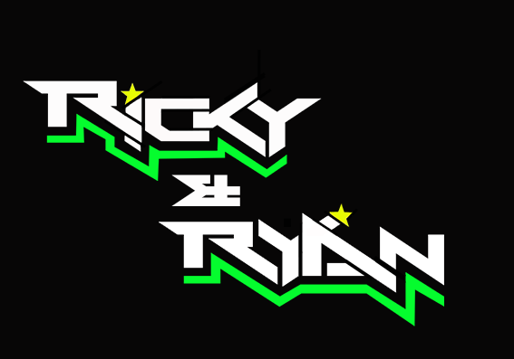

**News release**

19th September 2016

**Triple Podium Finish for Ricky and Ryan at Donington**

**F1 sidecar champions** [**Ricky Stevens and Ryan Charlwood**](http://www.teamrickyandryan.com) **had an action-packed weekend at Donington where they managed to secure three podium finishes and extend their lead in the** [**championship**](http://www.rkb-f1-sidecars.com)**.**

Sidecar driver Ricky Stevens, from Portsmouth, and his passenger Ryan Charlwood, from Dover, were racing at the Leicestershire track this weekend for the seventh round of the British F1 Sidecar Championship.

The team had made the risky decision of changing the motor in their outfit since their last race six weeks ago. After spending a large part of the Friday filming with Mike Bushell for a BBC Breakfast feature, they worked late into the night making some final adjustments to their new Kawasaki ZX10R engine.

With a comfortable but not fully secure lead in the rankings, the pair’s goal going into this round was to increase their advantage over their main rivals Tim Reeves and Greg Cluze and the second place holders Ben Holland and Lee Watson.

Ryan said: “With a 33-point lead going in, the pressure was on to increase our advantage. As the defending champions, we are the ones to beat but we are determined to hold on to our title.”

On Saturday, Ricky and Ryan started in position three on the grid. Reeves and Cluze, who began the race in the lead, were black-flagged in the fourth lap, giving the lead to Holland and Watson. Ricky and Ryan gave chase and managed to slip through on the very last lap, claiming their fourth victory this season.

In the first race on Sunday, Ricky and Ryan were pipped to the top spot at the very last corner by Reeves and Cluze.

In the second race of the day, they had to contend not with one but with two world championship-winning teams. The British champions gave a good chase and managed to keep up the pace with the ‘crème de la crème’ in sidecar racing. This thrilling chase had the crowd on its toes throughout. In the end, Ricky and Ryan came third, extending their lead in the championship to 49 points.

Ricky said: “I’m really pleased with how the weekend turned out. Our goal was to extend our lead and we’ve managed to do that.

“Racing against Tim Reeves and Pekka Paivarinta was a once-in-a-lifetime experience and a dream come true. I remember watching these guys race years ago, admiring their skills and wondering who would ever be able to challenge them. Fast forward to yesterday and here we were, nose to tail with the very best. It was an amazing feeling!”

The next championship round will take place in Assen in the Netherlands on 30th September and 1st and 2nd October.

**Ends**

**Notes to editors:**

* Ricky and Ryan are the reigning British F1 Sidecars champions.
* They raced to victory in the 2015 championship for team AOS/Be Wiser with Ricky Stevens, from Portsmouth, as driver and Ryan Charlwood, from Dover, as co-rider.
* In 2015, they also beat the world champions by four seconds, effectively making them the best F1 sidecar racing team in the world at present.
* For the 2016 season, Ricky and Ryan have joined the Quattro Plant Cool Kawasaki team. The newly sponsored team has a new livery and the backing from Bournemouth Kawasaki. The Quattro Plant Cool team also includes British Superbike riders Luke Mossey and Filip Backlund and Supersport rider Andy Reid.

**For media information contact:**

**Sarah-Jane Freni**

**Account Director**

**Shooting Star**

**0117 3131120**

[**sarahjane@weareshootingstar.co.uk**](mailto:sarahjane@weareshootingstar.co.uk)

**[RickyRyan14Donington]**