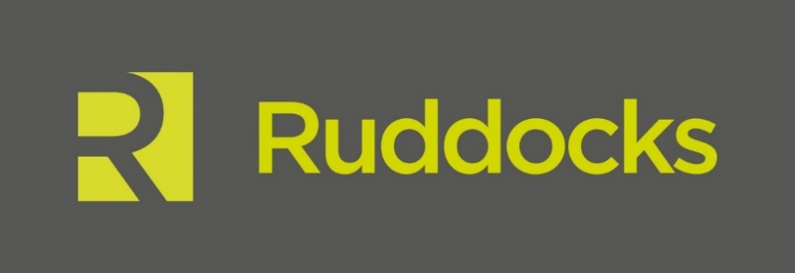

News Release

1st June 2016

Ruddocks Steels the Show at British Steel in Scunthorpe

The national media has descended on Scunthorpe today for the launch of the new British Steel, formerly part of Tata Steel, and the unveiling of the new brand which has been created by Lincoln-based agency Ruddocks.

Following a formal tender process and a competitive pitch, Ruddocks was awarded the contract in February this year by Longs Steel UK Limited.

Family Investment office Greybull Capital confirmed the signing of a sale and purchase agreement with Tata Steel in April and has resurrected the iconic British Steel name which disappeared when the organisation merged with Koninklijke Hoogovens to form Corus Group in 1999.

Ruddocks’ Managing Director Paul Banton along with several of the company’s designers are at today’s launch and said it is a very proud moment for the firm.

“To win the contract to rebrand the former Tata Steel’s Long Products Europe business, which includes not just the Scunthorpe steelworks but also several other locations across the UK & Ireland along with two sites in France, is a fantastic achievement for us,” explained Paul.

“Like British Steel, Ruddocks has a long heritage dating back to 1884 so there is a synergy between the two businesses. The old British Steel logo was iconic so it’s been an exciting challenge to come up with a new brand that we hope will be just as successful. In the run-up to today’s unveiling we’ve held focus groups with the employees at the Scunthorpe site and so far the feedback has all been positive. We’re now looking forward to hearing what the rest of the world thinks!

“This is a momentous occasion in the country’s steel industry and we are delighted to be part of it. British Steel is strong, both as a product and as an organisation, and the new brand has been designed to reflect this.”

The new logo is a combination of the B and S and is made up of three parts to represent the company’s core values of pride, passion and performance. The colours are derived from the elements of the steel-making process: molten orange signifies the start of something vibrant and exciting and the cool navy background colour is intended to represent the quality of the organisation - professional and committed.

British Steel Commercial Director Peter Hogg said: “Today is a landmark day for our new business. Our new brand represents everything we stand for – pride, passion and performance.

“We have a proud past but today is about the future and our brand represents a vibrant new business, renowned for producing world class steel and providing first class customer service.

“We are delighted to have been able to use a local business on this important project. Ruddocks have really impressed us by the way they have reflected British Steel, and our core values, through the development of our British Steel brand. Colleagues from across the business have worked in partnership with them to create the new identity which is simple yet distinctive symbolising progression and evolution.”

Ends

Notes to Editors

- Ruddock’s is a full-service design and print agency based in Lincoln.
- The agency has worked for local clients including Lincoln Cathedral and the University of Lincoln as well as national names such as Macdonald’s Hotels and Resorts, England Golf and NHS England.
- As well as an experienced and talented team of designers, Ruddocks has an in-house print and production facility, including litho, digital and large format equipment.
- For more information about Ruddocks please visit www.ruddocksdesign.co.uk

For further information about this news release please contact:

Kerri Saxby
Shooting Star
01522 528540
kerri@weareshootingstar.co.uk

