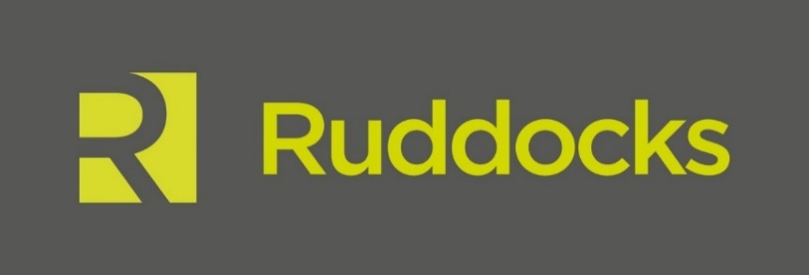

News Release

23rd January 2017

Can Ruddocks Steel the Show at European Awards?

The British Steel brand created by Lincoln-based design and print specialist Ruddocks has been shortlisted in five categories at the Transform Awards Europe.

The eighth annual Transform Awards Europe will celebrate the best practice in corporate, product and global brand development work and seek to reward excellence across the brand creation process.

Ruddocks has made the shortlist in five award categories for its work on the 2016 British Steel brand, during which the company’s design team created the new identity and comprehensive brand guidelines.

Andy Clayton, Brand Director at Ruddocks, said: “We’re overwhelmed to have been shortlisted in such prestigious industry awards. The whole Ruddocks team really poured their heart and soul into the British Steel project so to be in the running for five awards is a real pat on the back for everyone involved.

“We worked closely with creative agency Moirae, who developed British Steel’s online and digital presence, so we’re glad to see our collaborative work recognised on this international stage too.”

The Transform Awards Europe has categories in five main brand theme: content, process, strategy, type and sector. All finalists will also be considered for the Best Overall Visual Identity and the Grand Prix for Excellence in Rebranding awards, with winners announced on the night.

Ruddocks is on the shortlist for the Best Visual Identity in the Industrial/Basic Materials Sector; Best Rebrand of a Digital Property; Best Brand Evolution; Best Implementation of a Brand Development Project; and Best Internal Communications during a Brand Development Project awards.

The Ruddocks design team attended the launch event at the Scunthorpe steelworks in June 2016 when the new British Steel brand was unveiled for the first time in front of employees, stakeholders and the national press.

Ian Cant, Creative Director at Ruddocks, said: “While attending the launch we were able to see people’s reaction to the new brand at first hand and were delighted to hear so many positive comments, especially from the employees.”

Ruddocks worked closely with British Steel staff to create a new brand, which echoed the company’s values of pride, passion and performance, a process which the design team believe helped provide a feeling of ownership and empowerment.

Ian concluded: “We’ve received so much positive feedback for the new British Steel brand and I’m looking forward to celebrating with our team at the award ceremony.”

The category winners will be announced during a gala dinner on Thursday 30th March 2017 which will be held at The Brewery, in Central London.

Previous Transform Awards Europe winners include campaigns for Tesco, Lloyds Bank, Morrisons, BBC Newsbeat, Nuffield Health, TSB, British Gas.

For more information about Ruddocks please visit www.ruddocksdesign.co.uk

Ends

Notes to Editors

- Ruddocks is a full-service design and print agency based in Lincoln.
- Ruddocks is an established family run business with a history in Lincoln dating back to 1884.
- The agency has worked for local clients including Lincoln Cathedral and the University of Lincoln as well as national names such as Macdonald’s Hotels and Resorts, England Golf and NHS England.
- As well as an experienced and talented team of designers, Ruddocks has an in-house print and production facility, including litho, digital and large format equipment.
- For more information about Ruddocks please visit www.ruddocksdesign.co.uk

For further information about this news release please contact:

Kerri Saxby
Shooting Star
01522 528540
kerri@weareshootingstar.co.uk
[Ruddocks07Awards]

