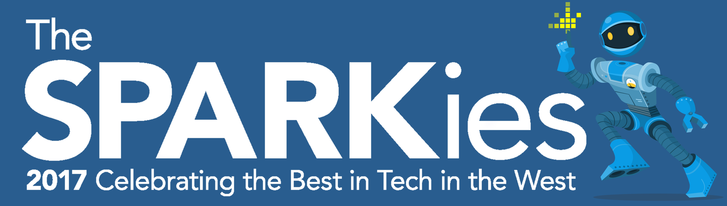
News release

10th May 2017

Last Call for Nominations for the SPARKies

With just 10 days to go until nominations close, the SPARKies have revealed their line-up of expert judges and the name of the comedian who will host the award ceremony.

The fifth annual SPARKies awards, headlined by Gradwell Communications, will shine a light on the best in tech across the Bristol, Bath, Somerset, Wiltshire and South Gloucester cluster.

The winners will be announced and celebrated at a ceremony on Thursday 29th June 2017 at the Komedia in Bath. Comedian Laura Lexx has been revealed as this year’s host.

Laura, who performed her solo show, Tyrannosaurus Lexx, at the Edinburgh Festival Fringe in 2016 is also known for co-hosting The Jason Manford Show on Absolute Radio.

The SPARKies have also revealed the 20 judges, all prominent figures in the South West tech scene, who will have the arduous task of selecting the people, products and companies who stand out the most across 15 award categories.

Abby Frear, Director of the SPARKies, said: “I’m delighted with the judging panel we have lined up. Our 20 judges are experts in their fields, innovative investors, serial entrepreneurs and creative geniuses. They know their stuff.

“If previous years are anything to go by, we can expect a minimum of 200 nominations. The judges’ task will be a challenging one and they will want to be impressed.”

Among the judges is Constance Fleuriot, Co-founder of the Women’s Tech Hub Bristol. She said: “I’m hoping to see something new and interesting, or well tried, tested and useful. I am quite open to being impressed by all sorts of tech activities.”

Andrew Mulvenna, Co-founder of Brightpearl, is also one of the judges. He said: “I want to support engineers with ambition to build big global businesses. I’m looking for the entrepreneurs who can solve the hardest problems and serve fundamental human needs by harnessing the South West’s deep engineering heritage.”

A full list of judges and a few helpful hints for applicants are available on the SPARKies website.

Nominations for the SPARKies close at midnight on Friday 19th May. To nominate someone or for more information, please go to: http://thesparkies.com

Additional information

(1) Eligibility:
All entrants to the SPARKies 2017 must be based within the region detailed on the following map: https://techspark.co/the-sparkies-awards-the-best-in-tech-in-the-west/sparkies-qualifying-region/.
If the organisation is headquartered elsewhere, but has a regional office in the qualification area, it may still enter the awards. However, the activities detailed in the entry must have been led from the qualifying office. The judge’s decision regarding eligibility of entries is final.

(2) Timeline:
Nominations close at midnight on Friday 19th May 2017.
A shortlist will be announced on Tuesday 6th June 2017 and the winners announced at an awards ceremony to be held in Bath on the evening of Thursday 29th June 2017.

(3) Categories:
- Best Start Up
- The ‘Totally Killing it’ Award
- The Lifetime Achievement Award
- Founder/ Entrepreneur of the Year
- Future Spark
- Best Digital Marketing Campaign
- The ‘Good’ Award
- Best Mentor / Advisor
- Best App
- Most Exemplary Use of Virtual & Mixed Reality
- The ‘Hard’ Award for best hardware
- Best Digital Design
- The Data, Data, Data Award
- Best Place to Work in Tech
- People’s Choice

(4) Judges:
- Monika Radclyffe, Centre Director, SETsquared Bristol
- Rosie Bennett, Entrepreneur in Residence, University of Bath Innovation Centre
- Andre Mulvenna, Investor
- Chris Dyson, Partner, Ashfords
- Constance Fleuriot, Co-Founder, Women’s Tech Hub Bristol
- Lily Smith, VP Product
- Tatjana Humphries, Senior Inward Investment Executive, Invest Bristol and Bath
- Emma Jones, Founder, Enterprise Nation
- Rekha Mehr, Corporate Innovation Expert, Just Eat Ventures
- Julien St. John-Dennis, Chief Product & Marketing Officer, Gradwell Communications
- Tom Beasley, Head, Bristol & Bath Science Park
- Dominic Mills, Chief Technology Officer, Zone
- Elaine McKechnie, Director, Future Space
- Louis Spencer, Technology, Media & Telecoms Lead, NatWest
- Zahra Ash-Harper, Studio Producer, Pervasive Media Studio
- Dan Page, Creative Director, VR World Congress
- Mark Turpin, CEO, Yogscast
- Nic Hemley, Head of Development, Scott Logic
- Matt Clarke, Engineering Manager, Dyson
- Marina Traversari, Programme Manager, Oracle Startup Cloud Accelerator

Ends

Notes to editors:
- The SPARKies are the digital and tech awards for the South West, which have regularly been held in Bristol and Bath over the last five years.
- The SPARKies shine a light on the very best people, products and companies that make up the tech sector in Bristol, Bath and the broader South West of England region.
- The SPARKies are organised by TechSPARK, the information hub for all things tech in Bristol, Bath and the South West of England.
- For more information, please go to: http://thesparkies.com

For media information contact:
Sarah-Jane Freni
Account Director
Shooting Star
0117 3131120
sarahjane@weareshootingstar.co.uk
[Sparkies02LastCallNominations]

