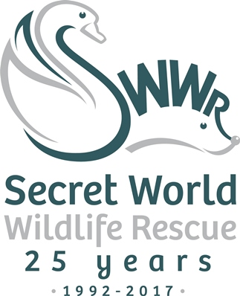
News release

8 March 2017

Secret World Launches Make a Will Week with Wards Solicitors

Secret World Wildlife Rescue in Somerset has teamed up with Wards Solicitors for its first ever Make a Will Week from 3 to 7 April 2017.

Three solicitors at Wards in Weston-super-Mare and Worle are donating their time to write wills for the general public in exchange for a donation for Secret World Wildlife Rescue.

Rebecca Parkman, Partner at Wards Solicitors, said: “We are strong believers in the value of the work done by the staff and volunteers at Secret World, so we are very happy to be involved with this initiative.

“We would encourage the charity’s supporters who are thinking of making a will but haven’t yet got around to it to get in touch.”

Secret World patron and former Blue Peter presenter Valerie Singleton added her support to the campaign, saying: “I am delighted to be a patron of Secret World – the work they do is of such great value to British wildlife. Please consider leaving a legacy gift which will, I know, make such a difference to the animals that come into their care.”

It is believed that more than half of the UK’s adult population has not made a will. Yet an up-to-date will written by a solicitor remains the best way of avoiding difficult decisions and legal complications for loved ones in the event of an untimely death.

Secret World’s Make a Will Week will take place from 3 April until 7 April. There is a recommended minimum donation of £95 for a single will or £150 for a pair of mirror wills which is substantially below the solicitors’ normal rate. And if supporters are able to Gift Aid their donation, then the contribution to helping Secret World’s work would be even greater.

All the proceeds from Make a Will Week will go to Secret World Wildlife Rescue in East Huntspill and will help them rescue, rehabilitate and release more than 5,000 wild animals and birds each year.

Those wishing to take part in Secret World’s Make a Will Week should call Wards Solicitors and make an appointment with the following solicitors:

Weston-super-Mare
Contact Rebecca Parkman or Katrina Bourton on 01934 413535

Worle
Contact Beth Niblett on 01934 428811
Ends

Notes to editors:
About Secret World Wildlife Rescue
- Secret World Wildlife Rescue is one of the South West’s leading wildlife rescue charities (charity number 1097119) based in East Huntspill in Somerset.
- Now in its 25th year, Secret World Wildlife Rescue cares for more than 5,000 sick, injured and orphaned animals each year.
- As well as being a respected source of expertise and a centre of excellence where British wildlife receives the best care, Secret World has an extensive volunteer programme and engages with schools to promote respect for wildlife and the environment, adding further benefits to the local community.
- As Secret World does not receive any government funding, it relies entirely on the generosity of supporters and donors to carry out this important work for British wildlife.
- The charity’s website is www.secretworld.org

For media information, please contact:

Sarah-Jane Freni
Shooting Star
0117 313 1120
sarahjane@weareshootingstar.co.uk
[SWWR09MakeaWillWeek]

