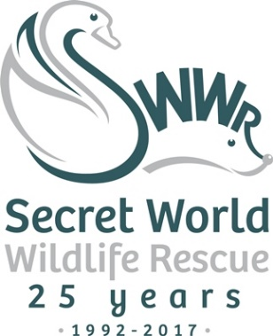
News Release
5th October 2017

Secret World Rescues Rare Bat
A rare grey long-eared bat has been rescued by Secret World Wildlife Rescue in East Huntspill, Somerset.

Secret World recently admitted the young bat that had been found grounded by a member of the public and handed over to a vet in Williton. Upon closer inspection, the bat was found to be underweight, dehydrated and unable to fly.

Daniel Clifford Bryant, animal carer at Secret World, said: “I had a suspicion that the bat was a grey long-eared bat when he came in but juvenile bats can be difficult to identify.

“Grey long-eared bats are one of the UK’s rarest species with an estimated population of only 1,000 to 3,000. They are mainly found in the south of the country and are part of the National Roost Monitoring Program. This means we had to be very vigilant with this bat as it is very important that it is released in the same place it came from.”

After a period of critical care and hand-feeding, the bat recovered well and was soon able to fly and feed by himself.

Part of the rehabilitation process for young bats includes some time spent in a secure outdoor flight pen so they can learn to catch flying insects by themselves. Secret World does not have the right facilities at present and so the bat was transferred to North Devon Bat Care to continue his rehabilitation.

Daniel said: “North Devon Bat Care was able to confirm that it was indeed a grey long-eared bat and through some detective work, I was able to locate the exact area where the bat had originally been found.

“He is now in a pen together with a female grey long-eared bat that was also found in Somerset and all being well, they will be able to go back to their home in the wild this autumn.”

Ends

Notes to editors:
About Secret World Wildlife Rescue
- Secret World Wildlife Rescue is one of the South West’s leading wildlife rescue charities (charity number 1097119) based in East Huntspill in Somerset.
- Now in its 25th year, Secret World Wildlife Rescue cares for more than 5,000 sick, injured and orphaned animals each year.
- As well as being a respected source of expertise and a centre of excellence where British wildlife receives the best care, Secret World has an extensive volunteer programme and engages with schools to promote respect for wildlife and the environment, adding further benefits to the local community.
- As Secret World does not receive any government funding, it relies entirely on the generosity of supporters and donors to carry out this important work for British wildlife.
- The charity’s website is www.secretworld.org

For media information please contact:

Sarah-Jane Freni
Account Director
Shooting Star
0117 4038200
sarahjane@weareshootingstar.co.uk

[28GreyLongEaredBat]

