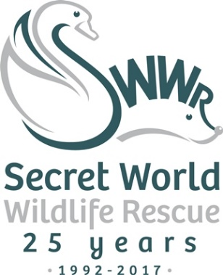
News Release
3rd November 2017

Holy Auction, Batman!

Secret World Wildlife Rescue in East Huntspill will be putting a lifesize replica of Batman (Arkham Knight) up for auction to raise funds for its bat rescue work.

When staff at the LOUD shop in Leicester heard that Secret World had recently rescued a very rare grey long-eared bat, they offered to donate a life-size replica of the famous comic figure to help the charity raise money for its work.

Antz White, e-Commerce Director at LOUD, said: “Batman coming to the rescue of bats was simply an opportunity too good to miss. Some members of staff are massive fans of bats and nocturnal mammals in general and were really keen for us to get involved.”

The Batman replica was manufactured by NECA in the US and is based on Batman: Arkham Knight, the final chapter in the acclaimed video game series.

Standing at a full 6' 2" tall, Batman was created directly from the digital files used in the making of the game. The figure is made of hand-painted foam rubber and latex and sports the Dark Knight's swirling fabric cape as a finishing touch.

Antz said: “It is a collectible piece and should capture the imagination of both Batman fans and Secret World supporters alike. We’re really keen to find out how it will do at auction.”

The auction will be taking place on eBay from 19th to 26th of November 2017. The link to the auction page will be posted on Secret World’s social media pages and website on the morning of 19th November.

Samantha Hannay, Head of External Relations at Secret World, said: “Secret World rescues, rehabilitates and releases approximately 60 bats each year. Recently, it rescued a grey long-eared bat which is one of the UK’s rarest species with an estimated population of only 1,000 to 3,000.

“The money we raise from this auction will help us provide vital funds for our bat rehabilitation work.”

For more information, please go to www.secretworld.org.
Ends

Notes to editors:
About Secret World Wildlife Rescue
- Secret World Wildlife Rescue is one of the South West’s leading wildlife rescue charities (charity number 1097119) based in East Huntspill in Somerset.
- Now in its 25th year, Secret World Wildlife Rescue cares for more than 5,000 sick, injured and orphaned animals each year.
- As well as being a respected source of expertise and a centre of excellence where British wildlife receives the best care, Secret World has an extensive volunteer programme and engages with schools to promote respect for wildlife and the environment, adding further benefits to the local community.
- As Secret World does not receive any government funding, it relies entirely on the generosity of supporters and donors to carry out this important work for British wildlife.
- The charity’s website is www.secretworld.org

About LOUD
- Loudclothing was founded back in 2005 with the aim of selling band T-shirts that were available stateside to music fans in Europe.
- LOUD works with bands and merchandise companies around the world to bring their customers special editions, hard-to-find designs and unique imports from Europe and North America.
- The LOUD team is passionate about music and the t-shirt industry. They are fans selling to fans and as such, take great care and pride in their business.

For media information please contact:

Sarah-Jane Freni
Account Director
Shooting Star
0117 4038200
sarahjane@weareshootingstar.co.uk
[SWWR33Batman]

