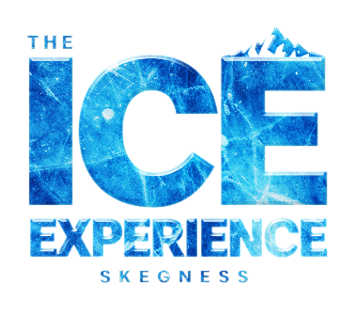
News release

27th May 2022

Brrrilliant! Unique -10 degree Ice Experience Comes to Skegness
The Hive, one of the premier entertainment complexes in Lincolnshire, is launching the UK’s only -10 degree all year-round Ice Experience with immersive 4D effects.
The concept promises to be an all-encompassing 4D experience, throughout which visitors will experience an interactive pre-show storyline. The creative team behind the attraction has also worked on projects worldwide including Game of Thrones and Disney’s Frozen the Musical.
To launch the Ice Experience on Saturday 23rd July 2022 there will be live ice sculpturing performances at various locations throughout the resort along with a range of other ice-themed activities before dignitaries, local MPs and VIP’s officially open the venue that afternoon.
Members of the public and competition winners will then be invited to try the new Ice Experience for themselves.
Matthew Dickinson, Creative Director for the experience, said: “The Ice Experience has been in planning for almost three years and we are excited to bring this innovative new attraction to Skegness which will provide unique and phenomenal family and adult entertainment – an experience like no other!
“It will be the only year-round Ice Experience in the UK and will further elevate Skegness as a premier holiday destination for anyone looking for something spectacular. Following on from the “roaring” success of the Supercar VIP Lounge, which resides within the same complex and boasts being the only bar in the UK with a fully functioning Lamborghini Huracan as its centrepiece.”
Matthew added: “The creative team have done an incredible job and the new attraction has surpassed expectation.
“For anyone planning to visit the area this summer tickets can be pre-booked online from 1st July 2022.
“Details will soon be revealed about our exclusive VIP launch party – watch this space!”

To find out more about The Ice Experience Skegness and to keep up to date with the latest news and bar launches, visit the website here or follow on Facebook and Instagram.

To pre-book tickets to the Ice Experience from 1st July click here.

Ends

Notes to editors:
- Based in the heart of Skegness (aka SkegVegas), one of the most popular seaside destinations in the UK, The Hive is a multi-million-pound entertainment complex, home to a variety of entertainment experiences and food venues.
- To find out more about The Hive follow the company on Facebook and Instagram, or with the hashtag #TheHiveSkegVegas

For media information please contact:
Maz Davis
Account Director
Shooting Star
maz@weareshootingstar.co.uk
01522 528540
[TheHive06IceExperiencePreLaunch]

