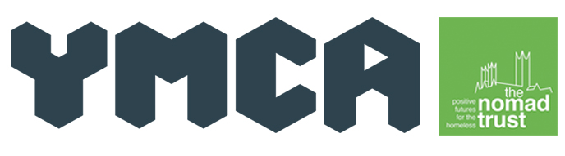
News release

15th April 2015

Lincs YMCA on the Ball to Tackle Homelessness in Lincoln

Staff and volunteers from Lincolnshire YMCA will host a black tie event next month to raise funds to help fight homelessness in the county.

On Saturday 2nd May 2015 Lincolnshire YMCA will host a charity ball at The Showroom Conference and Activity Centre on Tritton Road in Lincoln.

Julie Audis, Lincolnshire YMCA Housing Support Worker, and her sister Donna Baxter – who occasionally volunteers for the charity – came up with the idea of organising the charity ball as a way to fund raise for the charity’s housing department.

“Homelessness is a serious problem within our community,” explained Julie. “We are working extremely hard with the Nomad Trust to deal with this issue, and also to help give those who use our hostel service a helping hand as they move on to independent living.”

Guests attending the black tie event will be welcomed with a drinks reception. They will enjoy a four-course meal, live music entertainment and a disco.

Auction prizes currently available on the night include a signed photo of Prime Minister David Cameron, a 30-minute private jet flight around Lincoln and jewellery from Pandora.

Earlier this year the charity’s housing department experienced a £600,000 loss in Lincolnshire County Council grant funding.

In previous years the grant funds covered the cost of the resources used by the housing department to get service users equipped to live on their own.
Malcolm Barham, Chief Executive of Lincolnshire YMCA, explained: “We have started thinking of innovative ways to raise more funds to enable us to continue offering our great services to the residents and businesses in Lincolnshire.”

Julie is hopeful that the charity ball will be a great success and possibly become an annual event.

“This is the first ball the charity has hosted in a while, and this is my first opportunity to organise an event of this size!

“We are hoping to raise £3,000, which I think we will achieve with the help and generosity of those attending our charity ball.”

The Lincolnshire YMCA Charity Ball will begin at 7pm and end at 12.30am.

Tickets and tables seating up to ten people are available costing £35 per person. Tables can also be sponsored for £50. To make a booking or to donate an auction or raffle prize please contact The Showroom on 01522 508 360 or email: conference@showroom.com.

Ends

Notes of Editors:

- Lincoln YMCA was founded in 1869 and became Lincolnshire YMCA in 2005 when it merged with the Stamford branch.
- Lincolnshire YMCA is based on St Rumbold’s Street in Lincoln.
- Lincolnshire YMCA merged with Nomad Trust in 2013 to help people secure and sustain tenancies in the city as well as providing ongoing support once housed.
- Lincolnshire YMCA is one of the biggest providers of supported accommodation in Lincoln, and the only provider of night shelter in the county.
- In 2014 Lincolnshire YMCA provided 374 people with accommodation and is currently housing 109 residents aged from 18 to 66.
- Lincolnshire YMCA provides alternative education provision for vulnerable children to social housing, work-related training and international charity work around Europe.
- For more information about Lincolnshire YMCA, please visit http://www.lincsymca.co.uk, or the Lincolnshire YMCA Facebook page or follow their twitter account @LincsYMCA.

For more information about this news release please contact:
Shey Osibowale
Shooting Star PR
Tel: 01522 528540
Mob: 07538 674 832
shey@shootingstar-pr.co.uk
www.shootingstar-pr.co.uk
[YMCA05CharityBall]

